Superior University

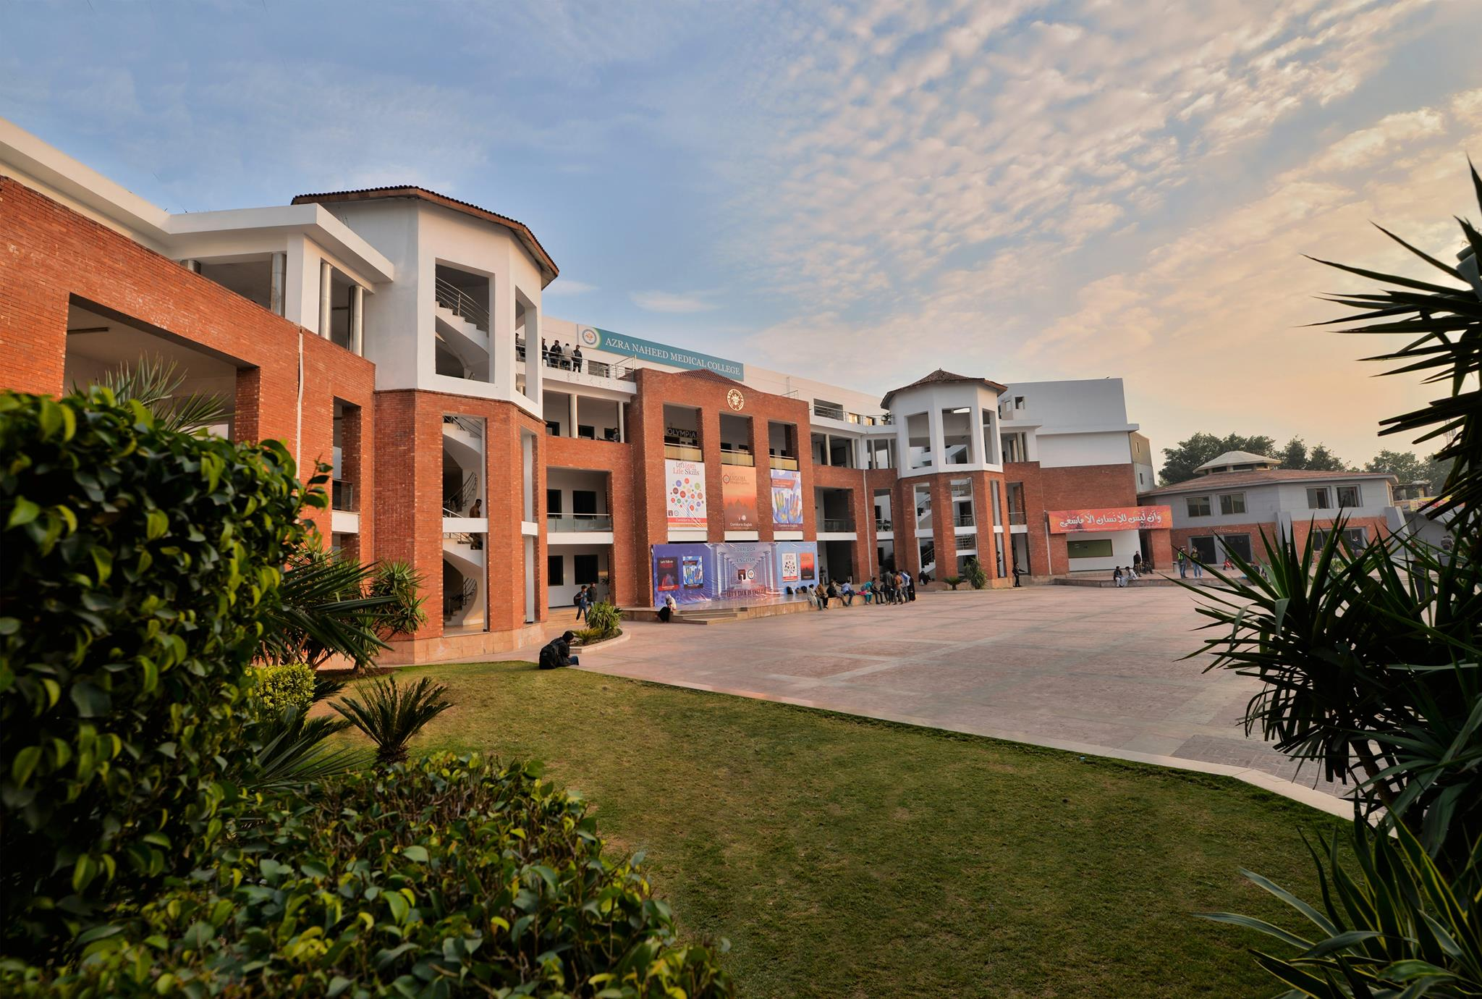 University Management System

**Group Members:-**

* **ALI SHERAZ**
  + **BCSM-F17-107.**
  + **BSCS-2B.**
* **HAMZA EJAZ**
  + **BCSM-F17-102.**
  + **BSCS-2C.**

**Course Instructor:**

**MAM AMNA KHAN.**

**CS & IT.**

**Superior University.**

**Introduction:**

About University Management System (UMS) UNIVERSITY MANAGEMENT SYSTEM is a flagship product of Easy Solution which covers all aspects of Universities. UMS covers every minute aspects of universities work flow and integrates all processes with user friendly interface. UMS is an outcome of hard work done by our team.

This program base on 3 persons:

**Admin (111):**

In this program admin can add students and teacher’s new data and also can see entered data which is stored in a text file. Admin can also enter time table for student and teachers.

**Teacher (222):**

In this program teacher can mark student attendance. Teacher can entered student’s marks and can see his class time table.

**Student (333):**

In this program student can see his attendance and marks and their timetable.

We got idea from Superior University, Lahore UMS. We try our best to build it for practical use. In future we will look forward to update it in full dynamic software and also want to sale it in market IN SHA ALLAH.

We spend almost one week in Coding and try to use all maximum concepts of object oriented programming. We create total 4 classes.

1. **Login.**
2. **Admin.**
3. **Teacher.**
4. **Student.**

**Admin is base class of student, teacher and Login is independent Class.**

**INHERETANCE:**

LOGIN

USE FOR LOGIN IN TO PROGRAM WITH 3 OBJECTS.

1. ADMIN (PASSWORD=111)
2. TEACHER(PASSWORD=222)
3. STUDENT(PASSWORD=333)

**Flow Chart:**

Main Body

**Student**

* **Student Marks**
* **Student Attendance**
* **Student Timetable**

**Teacher**

* **Student Attendance**
* **Student Marks**
* **Teacher’s Timetable**

**Admin**

* **Teacher record**
* **Student record**
* **Student Timetable**
* **Teacher Timetable**

LOGIN CLASS

Functions:

|  |  |  |  |
| --- | --- | --- | --- |
| **Login** | **Admin** | **Teacher** | **Student** |
| Constructor  verification()  Destructor | Constructor  Student_data()  Teacher_data()  Student_timetable()  Seeing_Student_Record()  Seeing_Teacher_Record()  Exit()  Portal()  Destructor | Constructor  studentsMarks()  Seeing_Teacher_Time()  Student_Attendence()  Exit()  Portal()  Destructor | Constructor  Seeing_Student_Time()  Seeing_Student_Result()  Seeing_Student_Attendence()  Exit()  Portal()  Destructor |

Screenshots:

1.welcome Screen

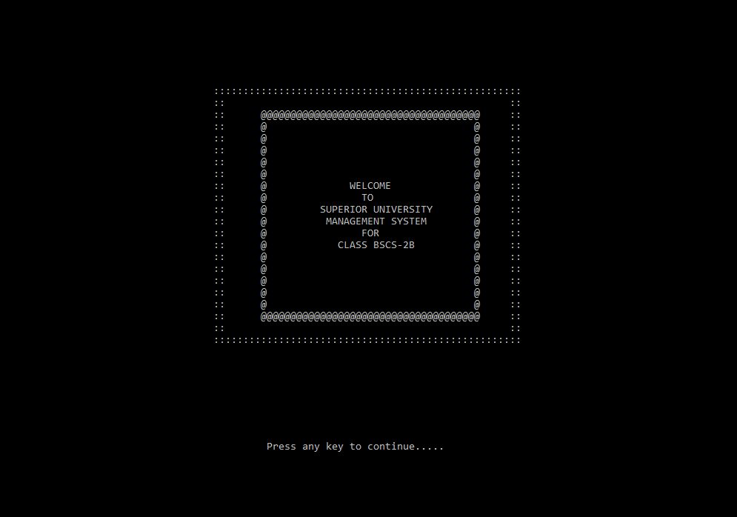

2.Login Page

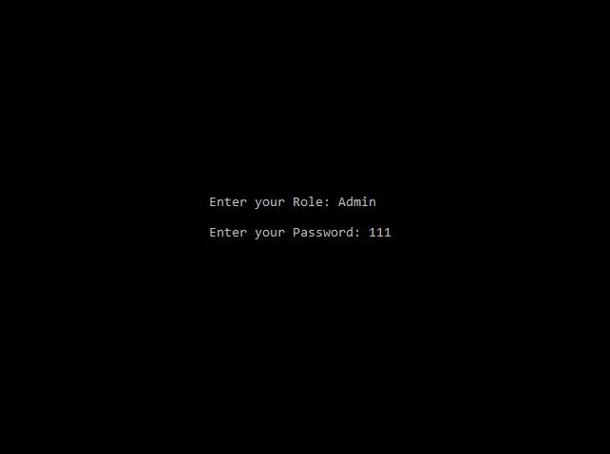

3.Admin portal

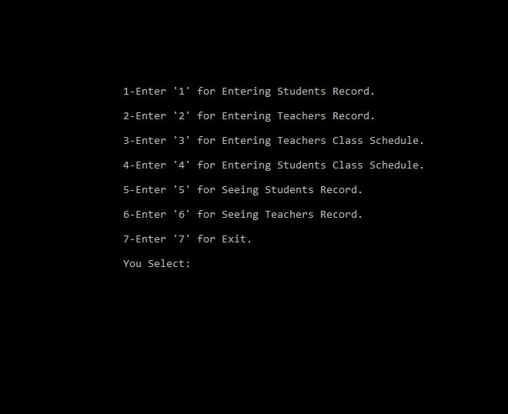

4.Student data from file

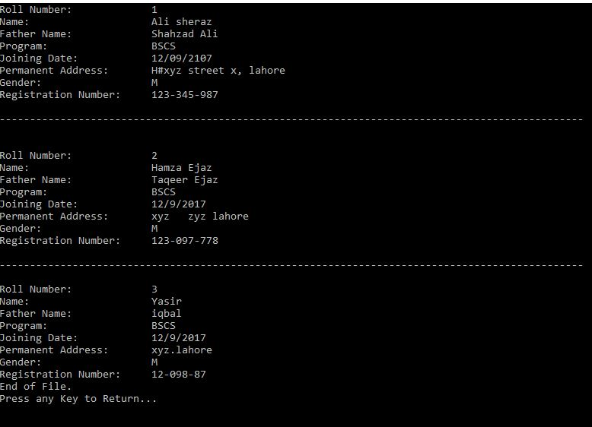

5.Teacher data from file

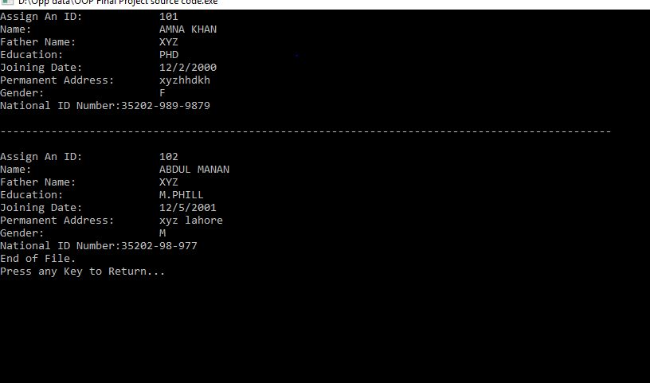

6.Teacher Portal

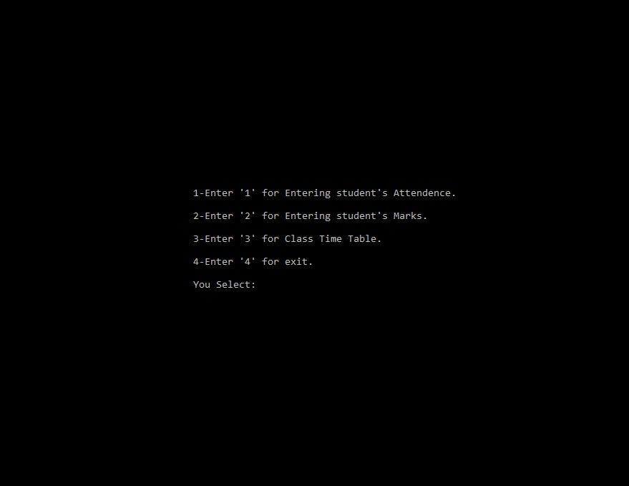

7.Teacher Time

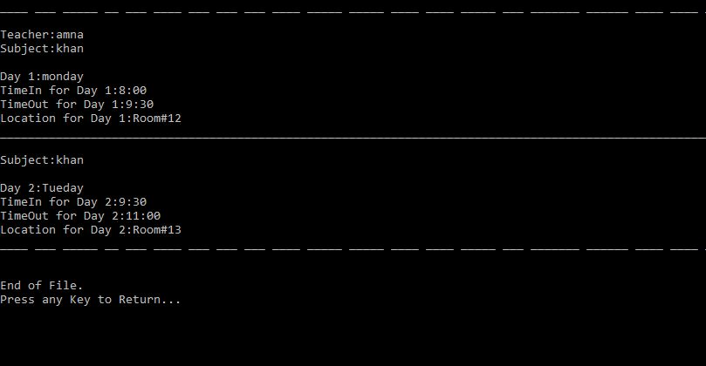

8.Student Marks from File

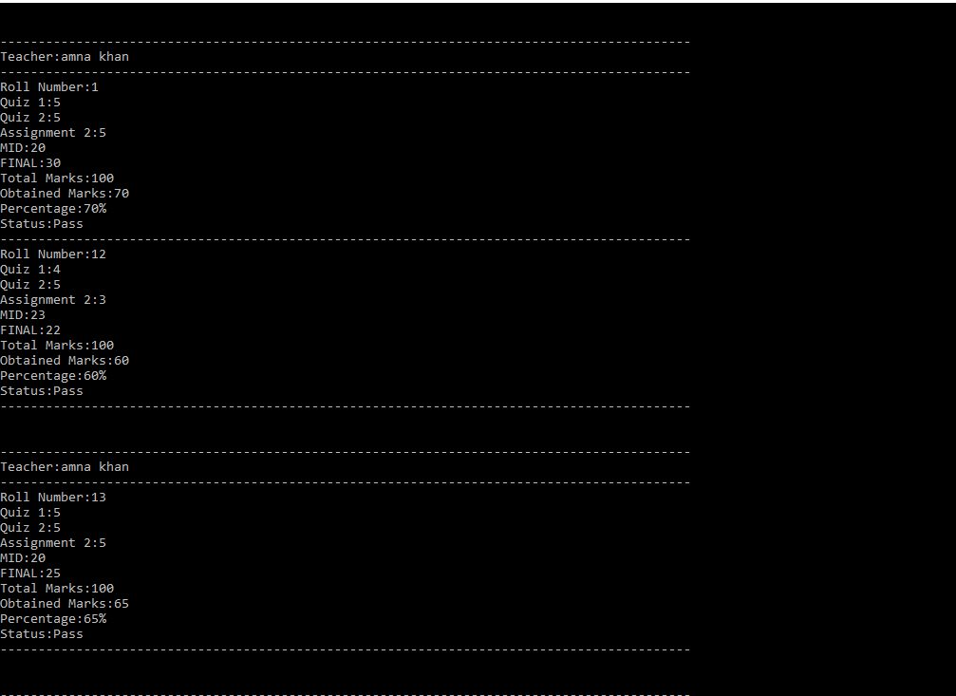

**Source Code:**

#include <iostream>

#include<iomanip>

#include<conio.h>

#include<fstream>

#include<string>

//#include<stdlib.h>

using namespace std;

///////////////////////////////////////////////////////////////////////////////////////////////////

void screenheader(); // welcome screen function declaration

void welcomenote(); // welcome note function declaration

void load(); //loading function declaration

void nextline(); //couple of lines space function declaration

///////////////////////////////////////////////////////////////////////////////////////////////////

class Admin

{

protected:

string optn;

string ReadData;

private:

string name,fname,program,education,room1,room2;

int rollnum;

char gender,day1[10],day2[10],timeIn1[5],timeOut1[5],timeIn2[5],timeOut2[5];

string date,address,formNumber,corseName;

ofstream stuData,TchrData,stuTime,TchrTime;

public:

Admin() { }

void Student_data() //student data function

{

stuData.open("StudentData.txt",ios::app);

char cho;

reproll:

system("CLS");

do

{

cout<<"Roll Number should be between 1 to 350."<<endl;

cout<<"Roll Number:"<<setw(13)<<" ";

cin>>rollnum;

stuData<<"Roll Number:"<<setw(13)<<" "<<rollnum<<endl;

if(rollnum<=350&&rollnum>=1)

{

cout<<"Name:"<<setw(20)<<" ";

cin.ignore();

getline(cin,name);

stuData<<"Name:"<<setw(20)<<" "<<name<<endl;

cout<<"Father Name:"<<setw(13)<<" ";

getline(cin,fname);

stuData<<"Father Name:"<<setw(13)<<" "<<fname<<endl;

cout<<"Program:"<<setw(17)<<" ";

getline(cin,program);

stuData<<"Program:"<<setw(17)<<" "<<program<<endl;

cout<<"Joining Date:"<<setw(12)<<" ";

getline(cin,date);

stuData<<"Joining Date:"<<setw(12)<<" "<<date<<endl;

cout<<"Permanent Address:"<<setw(7)<<" ";

getline(cin,address);

stuData<<"Permanent Address:"<<setw(7)<<" "<<address<<endl;

cout<<"Gender:"<<setw(18)<<" ";

cin.get(gender);

stuData<<"Gender:"<<setw(18)<<" "<<gender<<endl;

cout<<"Registration Number:"<<setw(5)<<" ";

cin.ignore();

getline(cin,formNumber);

stuData<<"Registration Number:"<<setw(5)<<" "<<formNumber<<endl;

}

else

{

cout<<"Roll Number should be between 1 to 350.\nPress any Key to Enter Agian..."<<endl;

getch();

goto reproll;

}

cout<<"\n------------------------------------------------------------------------------------------------\n\n";

stuData<<"\n------------------------------------------------------------------------------------------------\n\n";

cout<<"Want to Enter Again (Y/N):";

cin>>cho;

system("CLS");

}while(cho=='y'||cho=='Y');

Portal();

stuData.close();

}

void Teacher_data() //Techer data function

{

TchrData.open("TeacherData.txt",ios::app);

char cho;

reproll:

system("CLS");

do

{

cout<<"Please Filled all Feilds with Correct Information."<<endl;

cout<<"Assign An ID:"<<setw(12)<<" ";

cin>>rollnum;

TchrData<<"Assign An ID:"<<setw(12)<<" "<<rollnum<<endl;

cout<<"Name:"<<setw(20)<<" ";

cin.ignore();

getline(cin,name);

TchrData<<"Name:"<<setw(20)<<" "<<name<<endl;

cout<<"Father Name:"<<setw(13)<<" ";

getline(cin,fname);

TchrData<<"Father Name:"<<setw(13)<<" "<<fname<<endl;

cout<<"Education:"<<setw(15)<<" ";

getline(cin,education);

TchrData<<"Education:"<<setw(15)<<" "<<education<<endl;

cout<<"Joining Date:"<<setw(12)<<" ";

getline(cin,date);

TchrData<<"Joining Date:"<<setw(12)<<" "<<date<<endl;

cout<<"Permanent Address:"<<setw(7)<<" ";

getline(cin,address);

TchrData<<"Permanent Address:"<<setw(7)<<" "<<address<<endl;

cout<<"Gender:"<<setw(18)<<" ";

cin.get(gender);

TchrData<<"Gender:"<<setw(18)<<" "<<gender<<endl;

cout<<"National ID Number:"<<setw(6)<<" ";

cin.ignore();

getline(cin,formNumber);

TchrData<<"National ID Number:"<<setw(8)<<formNumber<<endl;

cout<<"\n------------------------------------------------------------------------------------------------\n\n";

TchrData<<"\n------------------------------------------------------------------------------------------------\n\n";

cout<<"Want to Enter Again (Y/N):";

cin>>cho;

system("CLS");

}

while(cho=='y'||cho=='Y');

Portal();

TchrData.close();

}

void Teacher_timetable(){

char cho;

int x=0;

system("cls");

cout<<setw(110)<<"Enter Teacher Time For Class 2B:"<<endl;

cout<<"If you want to Change Time you should have to enter again all Teacher Time Otherwise perivously Enter Overwrite.\n";

TchrTime.open("TeacherTime.txt");

TchrTime<<"____ ___ _____ __ ___ ____ ___ ___ ___ ____ _____ _____ ____ ____ _____ ___ _"<<endl;

D0{

cout<<setw(125)<<"\n\nPress any Key.....";

getch();

if(x==5)

{

cout<<setw(125)<<"\nMaximum Taecher In This is Class Covered.\n\nPress any Key.....";

getch();

TchrTime.close();

Admin::Portal();

}else

{

system("CLS");

cout<<"\nEnter Teacher:";

cin>>name;

cout<<"\nEnter Subject:";

cin>>corseName;

cout<<"\nEnter Day 1:";

cin>>day1;

cout<<"\nEnter TimeIn for Day 1:";

cin>>timeIn1;

cout<<"\nEnter TimeOut for Day 1:";

cin>>timeOut1;

cout<<"\nEnter Location for Day 1:";

cin.ignore();

getline(cin,room1);

cout<<"________________________________________________________________"<<endl;

cout<<"\nEnter Day 2:";

cin>>day2;

cout<<"\nEnter TimeIn for Day 2:";

cin>>timeIn2;

cout<<"\nEnter TimeOut for Day 2:";

cin>>timeOut2;

cout<<"\nEnter Location for Day 2:";

cin.ignore();

getline(cin,room2);

cout<<"__________________________________________"<<endl;

TchrTime<<"\nTeacher:"<<name<<"\nSubject:"<<corseName<<endl<<"\nDay 1:"<<day1<<endl<<"TimeIn for Day "<<timeIn1<<endl<<"TimeOut for Day 1:"<<timeOut1<<endl<<"Location for Day 1:"<<room1<<endl;

TchrTime<<"_____________________________________________________"<<endl;

TchrTime<<"\nSubject:"<<corseName<<endl<<"\nDay 2:"<<day2<<endl<<"TimeIn for Day "<<timeIn2<<endl<<"TimeOut for Day 2:"<<timeOut2<<endl<<"Location for Day 2:"<<room2<<endl;

TchrTime<<"____ ___ _____ __ ___ _________"<<endl;

}

cout<<"\n\nDo You Want to Enter Again (Y/N):";

cin>>cho;

x++;

}while(cho=='Y'||cho=='y');

TchrTime.close();

cout<<"\nPress any Key to Return..."<<endl;

getch();

Portal(); }

void Student_timetable()

{

char cho;

int x=0;

system("cls");

cout<<setw(110)<<"Enter Time For Class 2B:"<<endl;

cout<<"If you want to Change Time you should have to enter again all classes Time Otherwise perivously Enter Overwrite.\n";

stuTime.open("StudentTime.txt");

stuTime<<"____ ___ _____ __ ___ ____ ___ ___ ___ _________ _____"<<endl;

do

{

cout<<setw(125)<<"\n\nPress any Key.....";

getch();

if(x==5)

{

cout<<setw(125)<<"\nMaximum Subject In This is Class Covered.\n\nPress any Key.....";

getch();

stuTime.close();

Admin::Portal();

}

else

{

system("CLS");

cout<<"\nEnter Subject:";

cin>>corseName;

cout<<"\nEnter Day 1:";

cin>>day1;

cout<<"\nEnter TimeIn for Day 1:";

cin>>timeIn1;

cout<<"\nEnter TimeOut for Day 1:";

cin>>timeOut1;

cout<<"\nEnter Location for Day 1:";

cin.ignore();

getline(cin,room1);

cout<<"_______________________________________"<<endl;

cout<<"\nEnter Day 2:";

cin>>day2;

cout<<"\nEnter TimeIn for Day 2:";

cin>>timeIn2;

cout<<"\nEnter TimeOut for Day 2:";

cin>>timeOut2;

cout<<"\nEnter Location for Day 2:";

cin.ignore();

getline(cin,room2);

cout<<"________________________________"<<endl;

stuTime<<"\nSubject:"<<corseName<<endl<<"\nDay 1:"<<day1<<endl<<"TimeIn for Day 1:"<<timeIn1<<endl<<"TimeOut for Day 1:"<<timeOut1<<endl<<"Location for Day 1:"<<room1<<endl;

stuTime<<"___________"<<endl;

stuTime<<"\nSubject:"<<corseName<<endl<<"\nDay 2:"<<day2<<endl<<"TimeIn for Day 2:"<<timeIn2<<endl<<"TimeOut for Day 2:"<<timeOut2<<endl<<"Location for Day 2:"<<room2<<endl;

stuTime<<"____ ___ _____ __ ___ ____ ___ ___ ___ ____ _____ ______"<<endl;

}

cout<<"\n\nDo You Want to Enter Again (Y/N):";

cin>>cho;

x++;

}while(cho=='Y'||cho=='y');

stuTime.close();

cout<<"\nPress any Key to Return..."<<endl;

getch();

Portal();

}

void Seeing_Student_Record()

{

system("CLS");

ifstream stuDataR("StudentData.txt");

if(stuDataR.is_open())

{

while(getline(stuDataR,ReadData))

{

cout<<ReadData<<"\n";

}

stuDataR.close();

cout<<"End of File.\nPress any Key to Return..."<<endl;

getch();

Portal();

}

else {

cout<<"Unable to Open File OR File Removed.\nPress any Key to Return..."<<endl;

getch();

Portal();

} }

void Seeing_Teacher_Record()

{

system("CLS");

ifstream TchrDataR("TeacherData.txt");

if(TchrDataR.is_open())

{

while(getline(TchrDataR,ReadData))

{

cout<<ReadData<<"\n";

}

TchrDataR.close();

cout<<"End of File.\nPress any Key to Return..."<<endl;

getch();

Portal();

}

else

{

cout<<"Unable to Open File OR File Removed.\nPress any Key to Return..."<<endl;

getch();

Portal();

}

}

virtual void Exit()

{

system("CLS");

cout<<" "<<setw(98)<<"Thank you..........";

cout<<"\n"<<setw(102)<<"Press any key to Exit.";

getch();

exit(0);

}

void Portal()

{

load();

cout<<"\a";

choice:

system("cls");

nextline();

cout<<"\n"<<setw(123)<<"1-Enter '1' for Entering Students Record."<<endl;

cout<<"\n"<<setw(123)<<"2-Enter '2' for Entering Teachers Record."<<endl;

cout<<"\n"<<setw(131)<<"3-Enter '3' for Entering Teachers Class Schedule."<<endl;

cout<<"\n"<<setw(131)<<"4-Enter '4' for Entering Students Class Schedule."<<endl;

cout<<"\n"<<setw(121)<<"5-Enter '5' for Seeing Students Record."<<endl;

cout<<"\n"<<setw(121)<<"6-Enter '6' for Seeing Teachers Record."<<endl;

cout<<"\n"<<setw(103)<<"7-Enter '7' for Exit."<<endl;

cout<<"\n"<<setw(93)<<"You Select:";

cin>>optn;

if (optn=="1")

{Student_data();}

else if (optn=="2")

{ Teacher_data(); }

else if (optn=="3")

{ Teacher_timetable();}

else if (optn=="4")

{ Student_timetable(); }

else if (optn=="5")

{ Seeing_Student_Record(); }

else if (optn=="6")

{ Seeing_Teacher_Record(); }

else if (optn=="7")

{ Exit(); }

else

{

cout<<"\n"<<setw(113)<<"You Enter Wrong Choice.\n";

cout<<"\n"<<setw(105)<<"Press any key to Select Again....";

getch();

goto choice;

}

}

~Admin() { /*cout<<"distructor"; getch(); */ }

};

class Teacher: public Admin

{

private:

int absent,present;

string optn;

char section[8];

string name,date;

int roll,Q1,A1,MID,Q2,A2,FINAL;

float percentage;

ofstream stuMark,stuAtten;

public:

Teacher() {}

void studentsMarks()

{

stuMark.open("StudentMark.txt",ios::app);

int cho,ob=0; // change value of numStu

char ch;

string nameT;

repeat:

nextline();

system("CLS");

cout<<"\n"<<setw(107)<<"Please Provide Your Name:";

cin.ignore();

getline(cin,nameT);

stuMark<<"\n\n-------------------------------------------------------------------------------------------"<<endl;

stuMark<<"Teacher:"<<nameT<<endl;

stuMark<<"-------------------------------------------------------------------------------------------"<<endl;

cout<<"\n"<<setw(107)<<"Select Your Subject code:"<<endl;

cout<<"\n"<<setw(101)<<"Select '1' for OOP."<<endl;

cout<<"\n"<<setw(118)<<"Select '2' for COMMUNICATION SKILLS."<<endl;

cout<<"\n"<<setw(120)<<"Select '3' for MULTIVARIABLE CALCULUS."<<endl;

cout<<"\n"<<setw(118)<<"Select '4' for DIGITAL LOGIC DESIGN."<<endl;

cout<<"\n"<<setw(117)<<"Select '5' for DISCREATE STRUCTURE."<<endl;

cout<<"\n"<<setw(93)<<"You Select:";

cin>>cho; cout<<endl;

system("CLS");

if(cho==1)

cout<<"\n"<<setw(107)<<"Hi! Mam Amna Khan."<<endl;

else if(cho==2)

cout<<"\n"<<setw(107)<<"Hi! Sir Zahid Asraf."<<endl;

else if(cho==3)

cout<<"\n"<<setw(107)<<"Hi! Mam Sidra Siddiqi."<<endl;

else if(cho==4)

cout<<"\n"<<setw(107)<<"Hi! Sir Umair Khan."<<endl;

else if(cho==5)

cout<<"\n"<<setw(107)<<"Hi! Sir Mozzam."<<endl;

cout<<"Press any Key to continue...";

getch();

do

{

system("CLS");

roll1again:

cout<<"\n\nEnter Student Roll Number."<<endl;

cout<<"You Enter:";

cin>>roll;

if(roll>=1&&roll<=350)

{

stuMark<<"Roll Number:"<<roll<<endl;

q11again:

cout<<"\n\nEnter Student Quiz 1 Marks Out of 5."<<endl;

cout<<"You Enter:";

cin>>Q1;

if(Q1>5)

{

cout<<"\n"<<setw(107)<<"You Enter Incorrect marks.";

goto q11again;

}

stuMark<<"Quiz 1:"<<Q1<<endl;

q21again:

cout<<"\n\nEnter Student Quiz 2 Marks Out of 5."<<endl;

cout<<"You Enter:";

cin>>Q2;

if(Q2>5)

{

cout<<"\n"<<setw(107)<<"You Enter Incorrect marks.";

goto q21again;

}

stuMark<<"Quiz 2:"<<Q2<<endl;

a11again:

cout<<"\n\nEnter Student Assignment 1 Marks Out of 5."<<endl;

cout<<"You Enter:";

cin>>A1;

if(A1>5)

{

cout<<"\n"<<setw(107)<<"You Enter Incorrect marks.";

goto a11again;

}

a21again:

cout<<"\n\nEnter Student Assignment 2 Marks Out of 5."<<endl;

cout<<"You Enter:";

cin>>A2;

if(A2>5)

{

cout<<"\n"<<setw(107)<<"You Enter Incorrect marks.";

goto a21again;

}

stuMark<<"Assignment 2:"<<A2<<endl;

mid1again:

cout<<"\n\nEnter Student MID Marks Out of 40."<<endl;

cout<<"You Enter:";

cin>>MID;

if(MID>40)

{

cout<<"\n"<<setw(107)<<"You Enter Incorrect marks.";

goto mid1again;

}

stuMark<<"MID:"<<MID<<endl;

final1again:

cout<<"\n\nEnter Student FINAL Marks Out of 40."<<endl;

cout<<"You Enter:";

cin>>FINAL;

if(FINAL>40)

{

cout<<"\n"<<setw(107)<<"You Enter Incorrect marks.";

goto final1again;

}

stuMark<<"FINAL:"<<FINAL<<endl;

ob=Q1+Q2+A1+A2+MID+FINAL;

percentage=100*ob/100;

cout<<"\n"<<setw(107)<<"Total Subject Marks=100"<<endl;

stuMark<<"Total Marks:100"<<endl;

cout<<"\n"<<setw(96)<<"Roll Number "<<roll<<" Obtained Marks:"<<ob<<endl;

stuMark<<"Obtained Marks:"<<ob<<endl;

cout<<"\n"<<setw(96)<<"Roll Number "<<roll<<" Percentage:"<<percentage<<"%"<<endl;

stuMark<<"Percentage:"<<percentage<<"%"<<endl;

if(percentage<50)

{

cout<<"\n"<<setw(98)<<"Roll Number "<<roll<<" Status:Fail"<<endl;

stuMark<<"Status:Fail"<<endl;

}

else

{

cout<<"\n"<<setw(96)<<"Roll Number "<<roll<<" Status:pass"<<endl;

stuMark<<"Status:Pass"<<endl;

}

stuMark<<"-------------------------------------------------------------------------------------------"<<endl;

}

else

{

cout<<"\n"<<setw(107)<<"Incorrect Roll Number"<<endl;

goto roll1again;

}

cout<<"\n\n"<<setw(120)<<"Press 'Y' to Enter Next Roll Number:";

cin>>ch;

}while(ch=='y'||ch=='Y');

stuMark.close();

cout<<"\n\npress any key to return..";

getch();

system("CLS");

Portal();

}

void Seeing_Teacher_Time()

{

system("CLS");

ifstream TchrTimeR("TeacherTime.txt");

if(TchrTimeR.is_open())

{

while(getline(TchrTimeR,ReadData))

{

cout<<ReadData<<"\n";

}

TchrTimeR.close();

cout<<"\n\nEnd of File.\nPress any Key to Return..."<<endl;

getch();

Portal();

}

else

{

cout<<"Unable to Open File OR File Removed.\nPress any Key to Return..."<<endl;

getch();

Portal();

}

}

void Portal()

{

load();

cout<<"\a";

choice:

system("CLS");

nextline();

cout<<"\n"<<setw(123)<<"1-Enter '1' for Entering student's Attendence."<<endl;

cout<<"\n"<<setw(118)<<"2-Enter '2' for Entering student's Marks."<<endl;

cout<<"\n"<<setw(110)<<"3-Enter '3' for Class Time Table."<<endl;

cout<<"\n"<<setw(98)<<"4-Enter '4' for exit."<<endl<<endl;

cout<<" "<<setw(87)<<"You Select:";

cin>>optn;

if (optn=="1")

{

Student_Attendence();

}

else if (optn=="2")

{

studentsMarks();

}

else if (optn=="3")

{

Seeing_Teacher_Time();

}

else if (optn=="4")

{

Exit();

}

else

{

cout<<"\n"<<setw(113)<<"You Enter Wrong Choice.\n";

cout<<"\n"<<setw(105)<<"Press any key to Return...";

getch();

goto choice;

}

}

void Student_Attendence()

{

int x=0;

char cho;

system("cls");

if(x>60)

{

cout<<"The Maximum Limit of Student For this class Exceed.\nPress any Key to Return...";

getch();

Portal();

}

stuAtten.open("StudentAtten.txt",ios::app);

stuAtten<<"___________________________________________________________________________________________________________________"<<endl;

cout<<" "<<setw(95)<<"Enter the Date:";

cin.ignore();

cin>>date;

stuAtten<<"Date:"<<date<<endl;

cout<<"\n"<<setw(110)<<"Enter the Class and Section: ";

cin>>section;

stuAtten<<"Section:"<<section<<endl;

cout<<"\n"<<setw(123)<<"Enter 'P' for Present and 'A' for Absent.\n";

do

{

cout<<"\n\nPress Any Key to Enter.......";

getch();

system("CLS");

stuAtten<<"___________________________________________________________________________________________________________________"<<endl;

cout<<"\n"<<setw(93)<<"Roll Number:";

cin>>roll;

stuAtten<<"Roll Number:"<<roll<<endl;

cout<<"\n"<<setw(88)<<"Status:";

cin>>cho;

stuAtten<<"Status:"<<cho<<endl;

if(cho=='P'||cho=='p')

present++;

else

if(cho=='A'||cho=='a')

absent++;

stuAtten<<"___________________________________________________________________________________________________________________"<<endl;

cout<<" "<<setw(98)<<"Enter Again (Y/N):";

cin>>cho;

x++;

} while(cho=='Y'||cho=='y');

stuAtten.close();

cout<<"\n\nPress Any Key to Return.......";

getch();

Portal();

}

void Exit()

{

system("CLS");

cout<<" "<<setw(98)<<"Thank you..........";

cout<<"\n"<<setw(102)<<"Press any key to Exit.";

getch();

exit(0);

}

~Teacher() { /*cout<<"distructor"; getch(); */}

};

class Student: public Admin

{

public:

Student() {}

void Seeing_Student_Time()

{

system("CLS");

ifstream stuTimeR("StudentTime.txt");

if(stuTimeR.is_open())

{

while(getline(stuTimeR,ReadData))

{

cout<<ReadData<<"\n";

}

stuTimeR.close();

cout<<"\n\nEnd of File.\nPress any Key to Return..."<<endl;

getch();

Portal();

}

else

{

cout<<"Unable to Open File OR File Removed.\nPress any Key to Return..."<<endl;

getch();

Portal();

}

}

void Seeing_Student_Result()

{

system("CLS");

ifstream stuResultR("StudentMark.txt");

if(stuResultR.is_open())

{

while(getline(stuResultR,ReadData))

{

cout<<ReadData<<"\n";

}

stuResultR.close();

cout<<"\n\nEnd of File.\nPress any Key to Return..."<<endl;

getch();

Portal();

}

else

{

cout<<"Unable to Open File OR File Removed.\nPress any Key to Return..."<<endl;

getch();

Portal();

} }

void Seeing_Student_Attendence()

{

system("CLS");

ifstream stuAttenR("StudentAtten.txt");

if(stuAttenR.is_open())

{

while(getline(stuAttenR,ReadData))

{ cout<<ReadData<<"\n"; }

stuAttenR.close();

cout<<"End of File.\nPress any Key to Return..."<<endl;

getch();

Portal();

}

else {

cout<<"Unable to Open File OR File Removed.\nPress any Key to Return..."<<endl;

getch();

Portal(); } }

void Portal()

{

load();

cout<<"\a";

choice:

system("cls");

nextline();

cout<<"\n"<<setw(111)<<"1-Enter '1' for Your Attendence."<<endl;

cout<<"\n"<<setw(107)<<"2-Enter '2' for Your Result."<<endl;

cout<<"\n"<<setw(121)<<"3-Enter '3' for Time Table for Your Class."<<endl;

cout<<"\n"<<setw(100)<<"4-Enter '4' for exit."<<endl;

cout<<"\n"<<setw(91)<<"Your Select:";

cin>>optn;

if (optn=="1")

{Seeing_Student_Attendence();}

else if (optn=="2")

{ Seeing_Student_Result(); }

else if (optn=="3")

{ Seeing_Student_Time(); }

else if (optn=="4")

{ Exit(); }

else

{

cout<<"\n"<<setw(113)<<"You Enter Wrong Choice.\n";

cout<<"\n"<<setw(105)<<"Press any key to Return...";

getch();

goto choice; } }

~Student() { /*cout<<"distructor"; getch(); */}

};

class Login //for login into portal

{

private:

Admin A1;

Teacher T1;

Student S1; string role,password,phn;

int lastpass;

public:

Login() {}

void verification()

{

LogAgain:

system("CLS");

nextline();

cout<<" "<<setw(95)<<"Enter your Role: ";

cin>>role;

cout<<"\n"<<setw(100)<<"Enter your Password: ";

cin>>password;

if((role=="Admin"||role=="admin")&& password=="111")

{ A1.Portal(); }

else if((role=="Teacher"||role=="teacher")&&password=="222")

{ T1.Portal(); }

else

if((role=="Student"||role=="student")&&password=="333")

{ S1.Portal(); }

else{

char cho,cho1;

cout<<"\n"<<setw(113)<<"You Enter Wrong Role or Password.\n";

cout<<"\n"<<setw(102)<<"Forget Password? (Y/N):";

cin>>cho;

if(cho=='Y'||cho=='y')

{

system("CLS");

nextline();

cout<<"\n "<<setw(95)<<"Enter your Role: ";

cin>>role;

cout<<"\n"<<setw(103)<<"Enter your phone number:";

cin>>phn;

cout<<"\n"<<setw(103)<<"Last Password you Enter:";

cin>>lastpass;

if(role=="Admin"||role=="admin")

{

cout<<"\n"<<setw(102)<<"Your Password is '111'.";

}

else if(role=="Teacher"||role=="teacher")

cout<<"\n"<<setw(102)<<"Your Password is '222'.";

else if(role=="Student"||role=="student")

cout<<"\n"<<setw(102)<<"Your Password is '333'.";

cout<<"\n\n"<<setw(98)<<"Login Again? (Y/N):";

cin>>cho1;

if(cho1=='Y'||cho1=='y')

{ goto LogAgain; }

else

if(cho1=='N'||cho1=='n')

{

system("CLS");

cout<<" "<<setw(98)<<"Thank you..........";

cout<<"\n"<<setw(102)<<"Press any key to Exit.......";

getch();

exit(0); } }

else

{

system("CLS");

cout<<" "<<setw(98)<<"Thank you..........";

cout<<"\n"<<setw(102)<<"Press any key to Exit.......";

getch();

exit(0);

}}}

~Login() {/* cout<<" distructor"; getch(); */ }

};

int main()

{

Login l1;

system("COLOR 70");

for(int w=1;w<=10;w++) cout<<endl;

cout<<"\n\n\n"<<setw(110)<<"Press any key to continue..... ";

getche();

load();

l1.verification();

}

void load() //loading function

{ for(int x=1;x<=100;x++)

{

cout<<" "<<setw(118)<<"LOADING............."<<x<<"%";

system("cls");

}

}

void nextline() //couple lines space

{ for(int w=1;w<=20;w++)

cout<<endl;

}

**END OF FILE……………………………………..**

**THANKS**